Preparing the Way: a liturgy outline for parishes, deaneries and groups
Leaders’ notes
This outline is destined to be flexible. You may like to us it in the context of a Holy Hour – or as part of a parish meeting – or in small groups. It is possible to have one leader but there is scope to involve more people in reading the responses, scripture and reflections. There are ideas for a short ritual/ use of symbol towards the end of the liturgy – you might ask someone with an artistic flair to create a focal point using whichever of these you choose.

Introduction
Reader (use these or own words)
Our diocese has embarked on a three year period of reflection and renewal and Bishop Séamus has asked that we underpin it with prayer. Today/ tonight gives us an opportunity to focus our own minds and hearts on what Forward Together in Hope might mean for us individually – for our communities – and for our diocese. Our reflections will remind us that, when Jesus asks disciples to follow him, he does not always offer a clear road map of where he and the Holy Spirit will be taking them – but he does promise that he will be in it with us – wherever it takes us.
And so, let us tune into the presence of God with us here – and now… (pause for a moment of quiet)
Opening Responses
Reader We gather in the name of the Father:
All Who created us his sons and his daughters,
and placed us on the earth
to live the journey of a lifetime
and gave us companions to share the way.
Reader We gather in the name of the Son:
All Who calls disciples and friends to follow him –
along old paths and new ways –
to new encounters and to relived memories –
walking with us on the way to the Kingdom.
Reader We gather in the name of the Holy Spirit:
All Who inspires and cajoles,
who reassures and challenges
all whom the Lord calls –
encouraging them along the path that leads into a future
they may not yet be able to imagine –
or believe in.
Scripture Reading – Jesus calls the first disciples (Mark 1: 16-20) – as in Year B but other versions possible)

Sung Response (optional) E.g. Lord, you have come to the seashore , Follow me…
Reflection
Reader using these or own words.
(A PowerPoint is available to accompany this where facilities exist to show it – it simply illustrates some of the places and events referred to in the text. It will pay to practise running through this section so the reader and slide changer are confident!)
When Peter, Andrew, James and John – and later on, all the other disciples, left everything to follow Jesus, they did not know where he would be taking them…
They ended up travelling on desert roads – into wild places…
He had them going up mountains –
distributing bread and fish by lakesides –
crossing the Lake of Galilee in terrifying storms.
He took them to quiet villages and the firesides of friends –
and in amongst the hustle and bustle of big cities.
He took them to the holiest place in the Jewish religion –
and to areas where the Roman occupiers lived.
Sometimes he travelled with a small group –
and sent others off in pairs –
at other times they could not move because of the crowds.
They found themselves in debates with religious leaders – who often get a bad press – but who were trying to work out how what Jesus said tied in with the Law at the heart of their lives…
Jesus had them mixing with lepers – unclean women – blind people – messy and noisy children – and foreigners.
Jesus sent them on errands involving donkeys and buying food for meals.
He had them walking through the dirt (and worse) of first century Palestine – and then got down before them and washed their feet.
He took them into a garden – that became filled with soldiers… and there most of them stopped following him…
But those who could followed him in disgrace and humiliation to the foot of a cross until he went where they could not follow – into death and into a tomb.
And a few women did come back to that tomb – to anoint a decaying body… as they thought… only to be told that he was no longer there – that their journey continued… a journey to tell the others that he had risen and would be with them in Galilee.
And now Jesus did not just lead them – he came to them where they were – in an upper room – by the lakeside – on a hillside –
until the day came when he was again to go where they could not follow – but this time, his going was not to be an abandonment but an opening of a new way that they would follow in this life and on into the next…
a way that would be illuminated and fuelled by the power of the Holy Spirit..

Scripture Reading – Matthew 28: 16-20

“Behold I am with you until the end of time…”
This could the way into a time of Exposition/ Adoration or simply silence, reflecting on the promise of Christ to be with us – that the invitation to go forward together in hope includes him!
You could use the following words if necessary:
Jesus promised to be with us until the end of time. He is present to us today in the Blessed Sacrament. In a time of stillness, we can call to mind the places Jesus led his disciples into – and what those places might represent to us personally – and to our communities. We might ask the Lord where we find ourselves now… and open our hearts and minds to reflect on where he might be leading us next.

Going Forward Together in Hope
If appropriate, people might like to look at some simple ritual/ symbol at this point
Options
One symbol used in Forward Together in Hope is the mustard seed. You might like to have packets of easy-to-grow seeds and invite people to sow them into pots or into a piece of prepared ground in hopes that, over the coming months, they grow and blossom.
Another possibility might be to cut out footprints. Lay out a path – either of cloth or paper… deciding whether it leads further into the church or out of it! You could use this or a similar image at the front (A larger version of this picture is on the CD)
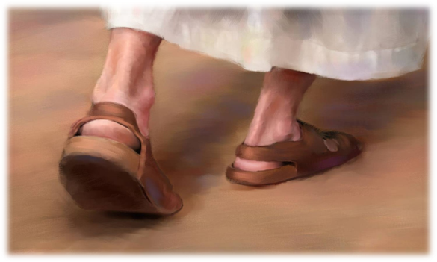
Invite people to lay their footprint on the path following Jesus.

Bidding Prayers
Reader We pray for our parish:
may we reflect wisely on the strengths and weaknesses –
looking at where God is at work among us
and where Christ might be calling us to go forward together.
Reader We pray for Bishop Séamus, the priests and deacons –
for Fr Jim O’Keefe and Tony Sacco who are heading up the process –
and for all who are taking a lead –
helping our diocese to discern how we can follow Christ more closely
and move forward together in hope.

Add more to suit your own circumstances…

Closing Prayer
Reader Lord Jesus, you honour all that is part of our past and our heritage
but from the beginning, have called men and women to travel –
to journey –
to follow you into places filled with fun and laughter
and to darker and more frightening places.
But always, you were with them –
leading them forward –
leading them together
leading them in hope.
All Bless us as we embark upon this journey –
our leaders and our companions
as we take our place in this great procession through history
joining those in our past and our future
travelling forward together –
with you –
in hope:
the Father, the Son and the Holy Spirit.

Closing Song The Summons… (or other option)

